***Solutions de exercices de révisions***

***Rappel***

|  |  |  |
| --- | --- | --- |
| x = -2  x = 3  x = 1  x = 1  x = $\frac{5}{2}$ x = -12 | x = 15  x = $\frac{14}{15}$ x = $\frac{14}{15}$ x = $\frac{5}{4}$ x = $\frac{9}{4}$ | x = 5  x = $\frac{7}{4}$ x = -1  x = 1  x = $\frac{1}{2}$ |

***Thème 1 : Polynômes***

1) d°A(x) = 3

Coefficient du terme de degré 3 = –5

Coefficient du terme de degré 1 = –1

A(x) est complet.

9 est le terme indépendant

x est la variable

A(2) = -25 A(1) = 5 A(0) = 9 A(-2) = 59 A(10) = -4801

2)

|  |  |  |  |
| --- | --- | --- | --- |
| 9a2 – 6ab + b2  a2 – 9b²  9a2 – 25  1 – 9b2  9a2 + 3a – 2  –9a2 + 42a – 49 | 4a2 – 12a + 9  4a2 – 25  64a2 + 16a + 1  – 16a2 – 24a – 9  – a2 – 4a – 4  25 – 36a2 |  |  |

3)

|  |  |
| --- | --- |
| –21x + x2  x2 + 20x – 16  – 5x2 – 4x + 26  5x2 – 9x + 12 | 20x2 – 8x – 8  3x3 – 79x2 + 103x – 4  1 – 76x2 – 75x3– 12x |

4)

|  |  |
| --- | --- |
| 4x³-3x²-5x+1 = (x-2).(4x²+5x+5) + 11  x³-2x²+x-3 = (x-3).(x²+x+4) + 9  -2x4+x³+3x²-8x+12 = (x+2).(-2x³+5x²-7x+6)  x5-3x²+1 = (x-1).(x4+x³+x²-2x-2)-1 | 2x³+6x²+x+3 = (x+3).(2x²+1)  x4-2x³-4x+16 = (x-4).(x³+2x²+8x+28) + 128  x³-64 = (x-4).(x²+4x+16)  x5-1 = (x+1).(x4-x³+x²-x+1) - 2 |

|  |  |
| --- | --- |
| 5) Aire colorée = L . l  = (30 – 2x) . (20 – 2x)  = 600 – 60x – 40x + 4x²  = 4x² - 100x + 600 | Aire des 4 petits carrés = 4x² |

Ainsi : 4x² - 100x + 600 = 4x²

-100x = 4x² - 4x² - 600

-100x = -600

x = 6 x vaut 6.

6)



7)



8)



9)



***Thème 2 : Le triangle rectangle***

***Pythagore et les racines carrées***

1)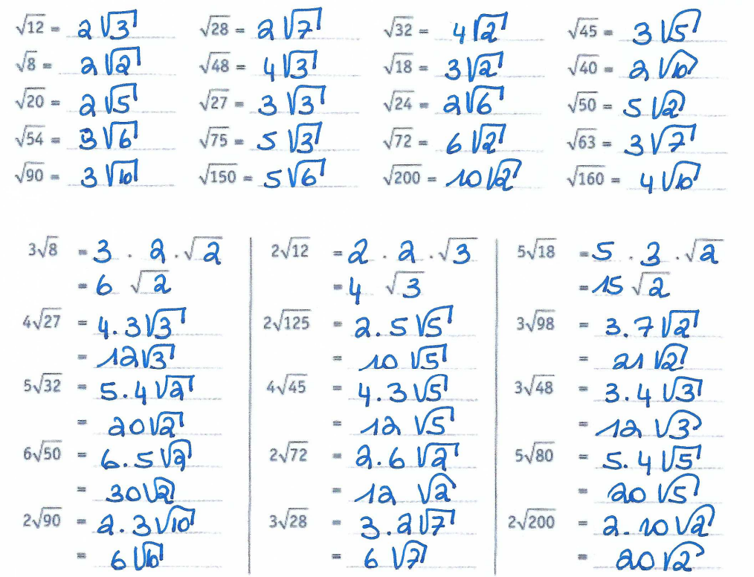

2)

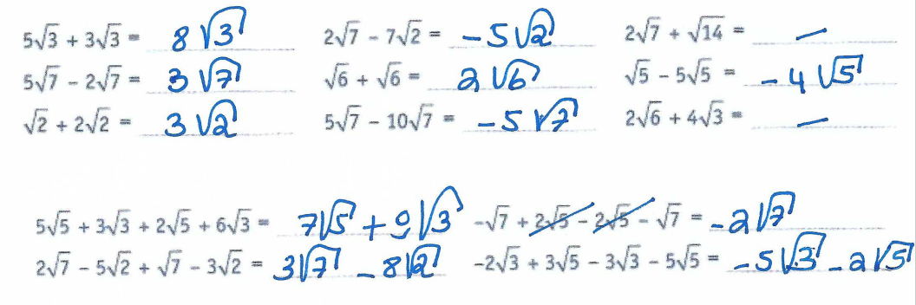

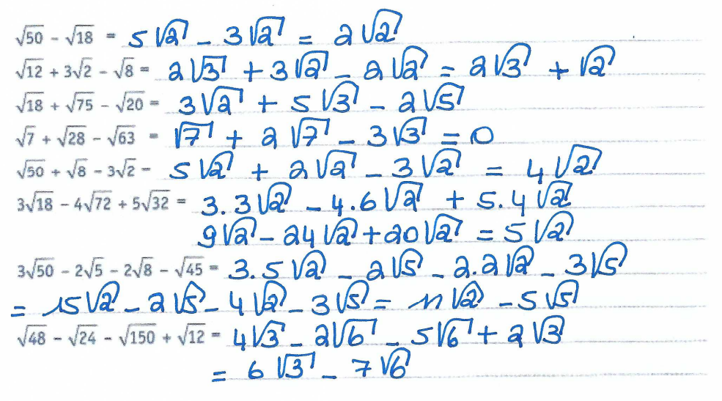

3)

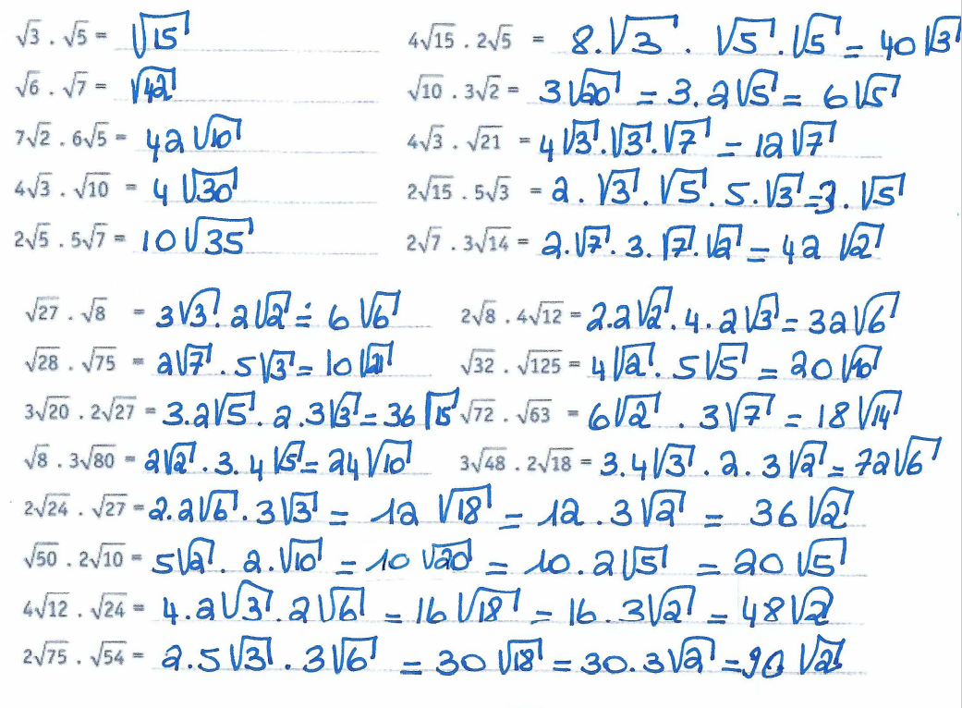

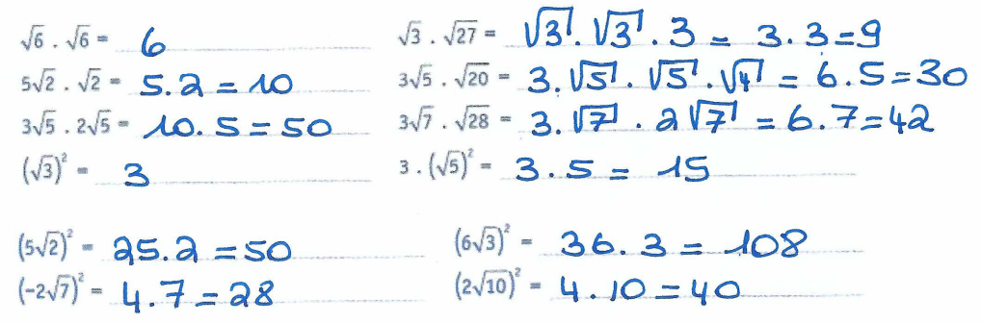

4) 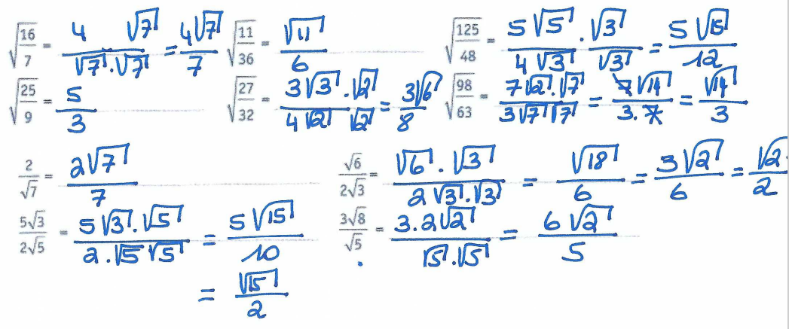

5)

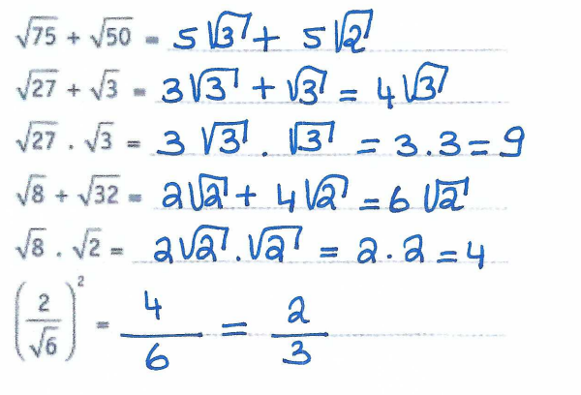

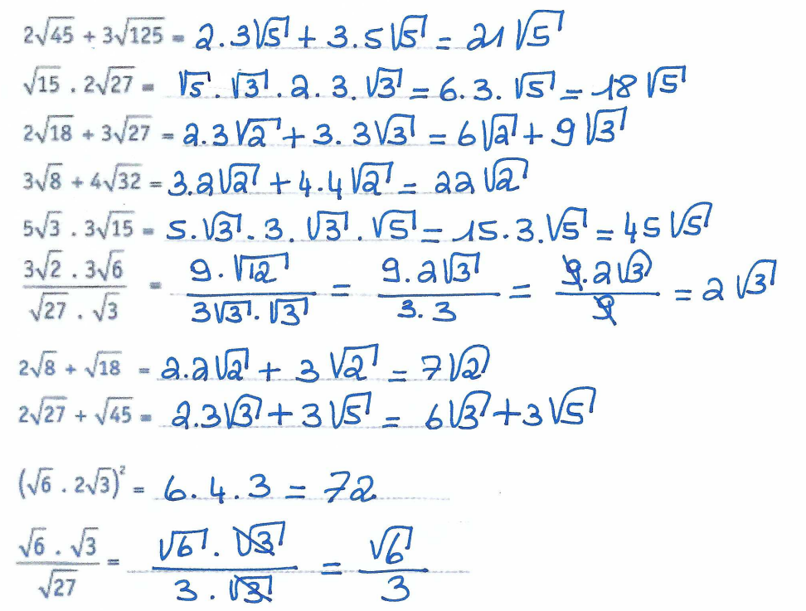

|  |  |  |
| --- | --- | --- |
| 6)  7) r s t  7 5  5 7  5 2  8) Hauteur du mur : 3,92 m ou 392 cm  9) x2 = 52+32  x2 = 25+9  x2 = 34  x=  10) 62=32+x2  36=9+x2  27 = x2  = x | | 11) x2 = 52+42  x2 = 25+16  x2 = 41  x =  12)  13) 972 = 722+652  9409 = 5184 + 4225  9409 = 9409  Comme l'égalité de Pythagore est vérifiée, le triangle est rectangle (réciproque). |
| 14) |  | |

|  |  |  |
| --- | --- | --- |
| 15) | a) |  |
|  |  |  |
|  | b) |  |
|  |  |  |
|  | c) |  |
|  |  |  |
|  | d) |  |

***Trigonométrie dans le triangle rectangle***

|  |  |  |  |  |  |  |
| --- | --- | --- | --- | --- | --- | --- |
| 1) |  | |BC| | |AC| | |AB| | || | || |
|  | a) | **100** | 70,71 | 70,71 | 45° | **45°** |
|  | b) | 41,41 | 10,72 | **40** | **15°** | 75° |
|  | c) | 26,93 | **10** | **25** | 21,8° | 68,2° |
|  | d) | **75** | **25** | 70,71 | 19,47° | 70,53° |
|  | e) | 1,2 | 0,96 | **0,72** | 53° | **37°** |
|  | f) | 8,17 | **7,21** | 3,83 | **62°** | 28° |
|  | g) |  | 0,93 | 1,07 | 41° | **49°** |

|  |  |  |  |  |  |  |  |  |  |
| --- | --- | --- | --- | --- | --- | --- | --- | --- | --- |
| 2) |  | cos B =  => || = 73,87°  L’inclinaison de l’échelle est de 73,87°. | | | 3) |  | | sin B =  => |AC| = 0,8682  On monte à une altitude de 868,24m. | |
|  |  |  | | |  |  | | |  |
| 4) |  | | tg B =  => || = 33,18° | | 5) |  | sinB =  =>|AC|= 178,20m  Le cerf-volant est à une altitude de 178,20m. | | |
|  |  |  | | |  |  | | |  |
| 6) |  | | | |AE| = |AC|+|CE|  or tgB =  => |AC| = 37,49m  => |AE| = 37,49 + 1,8 = 39,29  L’arbre mesure 39,29m. | | | | | |
|  |  |  | | |  |  | | |  |
| 7) |  | sinB =  => || = 75,16°  L’échelle fait un angle de 75,16° avec le sol. | | | 8) |  | | tgB =  => |AC|=12,7m  L’arbre mesure 12,7m. | |
|  |  |  | | |  |  | | |  |
| 9) |  | | |CD|=2.|AC|  Or sinB =  => |AC| = 5,36m  => |CD| = 10,72m  Le mât mesure 10,72m. | | | | | | |