|  |
| --- |
| ***Exercices de révisions - Correctif*** |

***Les équations du premier degré***

|  |  |  |  |
| --- | --- | --- | --- |
| 1) | x = -2  x = 3  x = 1  x = 1  x = $\frac{5}{2}$ x = -12 | x = 15  x = $\frac{14}{15}$ x = $\frac{14}{15}$ x = $\frac{5}{4}$ x = $\frac{9}{4}$ | x = 5  x = $\frac{7}{4}$ x = -1  x = 1  x = $\frac{1}{2}$ |

***Thème 1 : Les polynômes***

1) d°A(x) = 3

Coefficient du terme de degré 3 = –5

Coefficient du terme de degré 1 = –1

A(x) est complet.

9 est le terme indépendant

x est la variable

A(2) = -25 A(1) = 5 A(0) = 9 A(-2) = 59 A(10) = -4801

2)

|  |  |  |  |
| --- | --- | --- | --- |
| 9a2 – 6ab + b2  a2 – 9b²  9a2 – 25  1 – 9b2  9a2 + 3a – 2  –9a2 + 42a – 49 | 4a2 – 12a + 9  4a2 – 25  64a2 + 16a + 1  – 16a2 – 24a – 9  – a2 – 4a – 4  25 – 36a2 |  |  |

3)

|  |  |
| --- | --- |
| –21x + x2  x2 + 20x – 16  – 5x2 – 4x + 26  5x2 – 9x + 12 | 20x2 – 8x – 8  3x3 – 79x2 + 103x – 4  1 – 76x2 – 75x3– 12x |

4)

|  |  |
| --- | --- |
| 4x³-3x²-5x+1 = (x-2).(4x²+5x+5) + 11  x³-2x²+x-3 = (x-3).(x²+x+4) + 9  -2x4+x³+3x²-8x+12 = (x+2).(-2x³+5x²-7x+6)  x5-3x²+1 = (x-1).(x4+x³+x²-2x-2)-1 | 2x³+6x²+x+3 = (x+3).(2x²+1)  x4-2x³-4x+16 = (x-4).(x³+2x²+8x+28) + 128  x³-64 = (x-4).(x²+4x+16)  x5-1 = (x+1).(x4-x³+x²-x+1) - 2 |

Ex2 p69



Ex3 p69



Ex15 p73



Ex2 p6



Ex3 p69



Ex15 p73



Ex3 p74



**Thème 2 : Triangle rectangle : Les irrationnels**

1)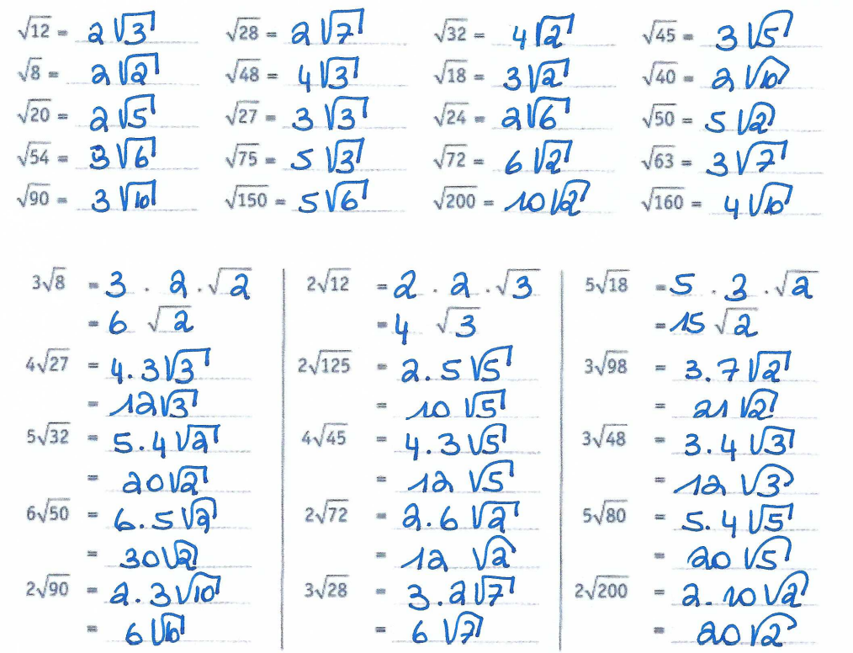

2)

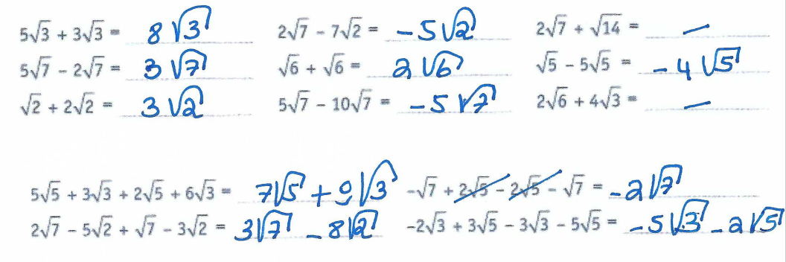

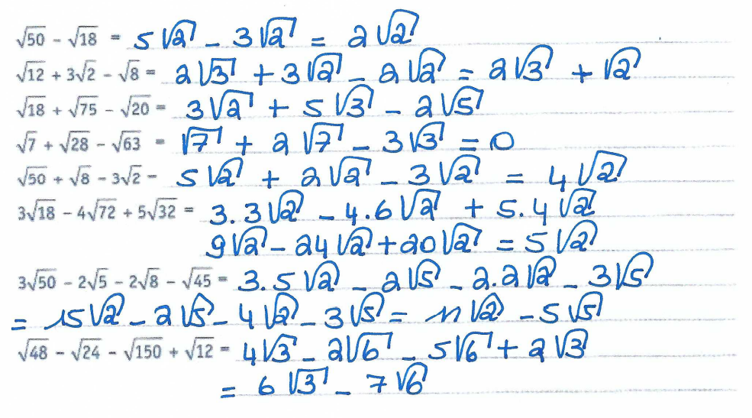

3)

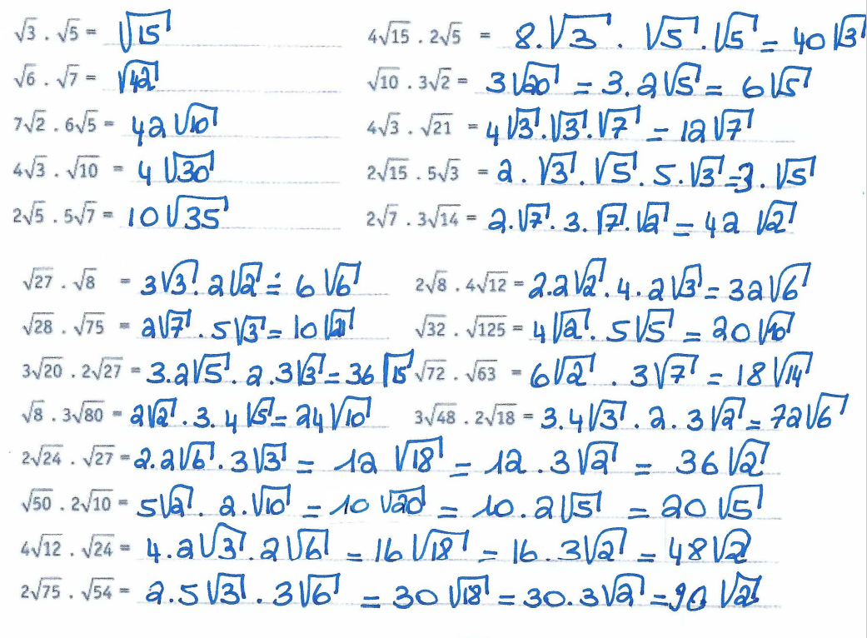

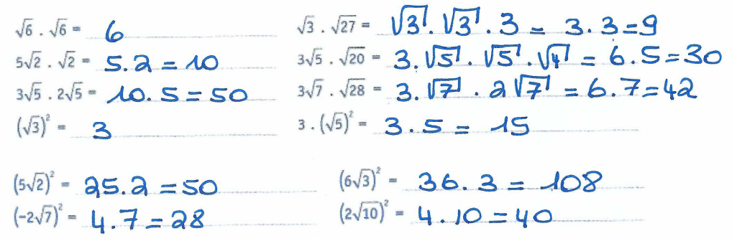

4) 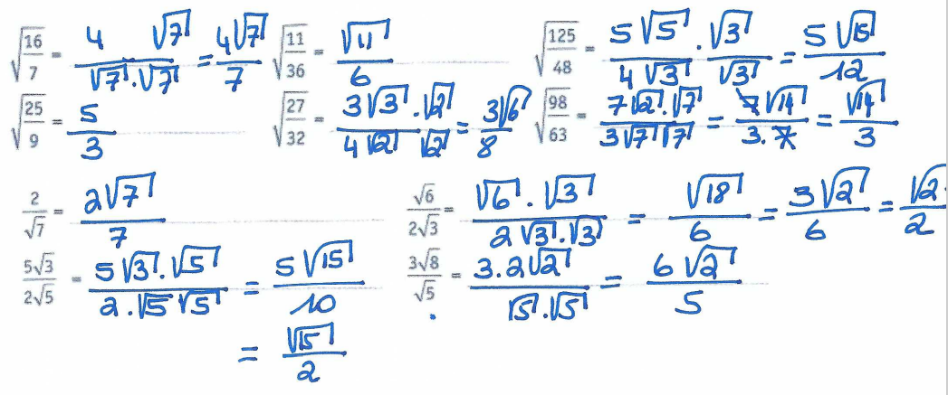

5)

